CSE420
Samuel Marrujo
Professor Yu
Lab 14

Clip
In this part of the lab, it was a modification of the original clip.cpp program. After some modifications to the program, and adding in the functions asked for, the result was the following reproduction of the figure. The removal of the glTranslatef() function ended up producing no image at all. This is because of the way the order of the process of Translatef() -> Rotatef() functions are used. After adding the gluLookAt() function, the figure is presented farther away. This is due to the camera being moved along the z-axis at a farther position than the original camera. Because of this change to the functions and the addition of the figure, I believe I was able to accomplish this task successfully, since there were no errors and the display window was changed. Here are my results for this program:
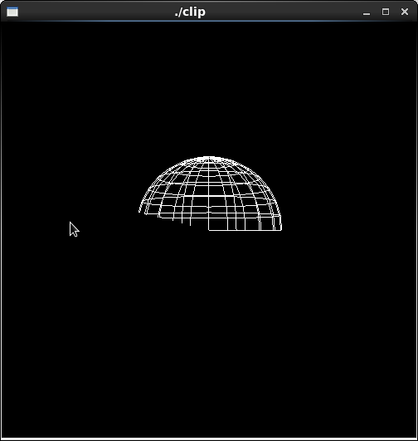

/*
* clip.cpp
* This program demonstrates arbitrary clipping planes.
*/
#include <GL/glut.h>

void init(void)
{
glClearColor (0.0, 0.0, 0.0, 0.0);
glShadeModel (GL_FLAT);
}

void display(void)
{
GLdouble eqn[4] = {0.0, 0.25, 0.0, 0.0};
GLdouble eqn2[4] = {0.25, 1.0, 0.0, 0.0};

glClear(GL_COLOR_BUFFER_BIT);

glColor3f (1.0, 1.0, 1.0);
glPushMatrix();
glTranslatef (0.0, 0.0, -5.0);
/* clip lower half -- y < 0 */
glClipPlane (GL_CLIP_PLANE0, eqn);
glEnable (GL_CLIP_PLANE0);
/* clip left half -- x < 0 */
glClipPlane (GL_CLIP_PLANE1, eqn2);
glEnable (GL_CLIP_PLANE1);

glRotatef (90.0, 1.0, 0.0, 0.0); //make z-axis vertical
/*
poles along z-axis, 20 longitudinal slices (passing through poles)
16 latitude cuts ( parallel to equator )
*/
glutWireSphere(1.0, 20, 16);
glPopMatrix();

glFlush ();
}

void reshape (int w, int h)
{
glViewport (0, 0, (GLsizei) w, (GLsizei) h);
glMatrixMode (GL_PROJECTION);
glLoadIdentity ();
gluPerspective(60.0, (GLfloat) w/(GLfloat) h, 1.0, 20.0);
glMatrixMode (GL_MODELVIEW);
}

int main(int argc, char** argv)
{
glutInit(&argc, argv);
glutInitDisplayMode (GLUT_SINGLE | GLUT_RGB);
glutInitWindowSize (500, 500);
glutInitWindowPosition (100, 100);
glutCreateWindow (argv[0]);
init ();
glutDisplayFunc(display);
glutReshapeFunc(reshape);
glutMainLoop();
return 0;
}

